Be R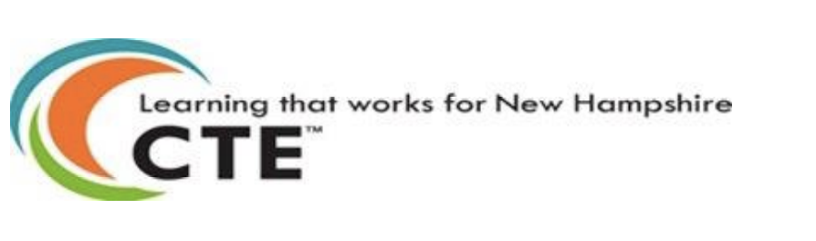

**Title**: Computer and Information Sciences, General.

**CIP#**: 110101

**Definition**: Computer and Information Science careers are available in every sector of the economy. Careers in CS & IT involve the design, development, support and management of hardware, software, networking and systems integration services. The computer and information science industry is a dynamic and entrepreneurial field that continues to have a revolutionary impact on the economy and on the world.

**This career cluster is organized into five career pathways**:

* Networking
* Data Science
* Programming
* Cybersecurity
* Systems Administration

**Careers**

Students in computer and information science learn and practice skills that prepare them for diverse post-high school education and training opportunities, from apprenticeships and two-year college programs to four-year college and graduate programs.

CTE classes in this cluster will introduce you to a variety of interesting careers including:

* Web Developer
* Mobile Application Developer
* Software Engineer
* Network Administrator
* IT Help Desk Technician
* IT Manager
* Database Administrator
* IT Security Specialist
* Systems Administrator (Windows and/or Linux)
* Computer Programmer
* IT Project Manager
* Computer Scientist
* Computer Hardware Engineer
* Robotics Engineer
* Network Architect
* DevOps Engineer
* Data Scientist
* User Interface Developer

**Note**: Each school and school district has different CTE options. Not every district has classes in every cluster, nor does every district offer CTE dual credit and Advanced Placement options.

COMMON COMPETENCIES

Upon completion of their selected pathway program, all NH CTE students will:

**CTE Professionalism and IT Essentials**

* Use correct terminology, vocabulary and appropriate language to communicate effectively in the workplace
* Select and safely use appropriate tools, supplies, and equipment for a specific task or set of tasks.
* Employ effective time and project management strategies to complete work efficiently and proficiently.
* Apply math concepts, including measurement, operations, and higher mathematics to relevant applications and specific tasks.
* Demonstrate awareness strategies to safely work in a variety of workspaces and locations.

PATHWAY COMPETENCIES

Upon completion of the Computer and Information Sciences general pathway, students will achieve competency in five areas.

Learner will be able to:

* **Algorithms and Programming**:
  + Create meaningful and efficient programs including choosing which information to use and how to process and store it, breaking apart large problems into smaller ones, recombining existing solutions, and analyzing different solutions.
* **Networks and the Internet**:
  + Apply networking concepts, using various models to implement protocols and standards when moving data. Design systems with working switching and routing "packets" to ensure data flows to the correct destination. Ensure data traffic flows through the internet effectively.
* **Computing Systems**:
  + Apply concepts of physical components and software that make up a computing system which communicate and process information in digital form, along with practices and methodology for troubleshooting issues in those systems.
* **Data and Analysis**:
  + Synthesize concepts, practices and processes of data collection, resource management, and techniques to different types of data in order to discover useful information that can communicate storytelling and to inform decision-making.
* **Cybersecurity**:
  + Prove how to detect, prevent and mitigate threats in order to secure a computing system or network in an ethical manner, and in accordance with international, federal,state, local and cyber laws and regulations.